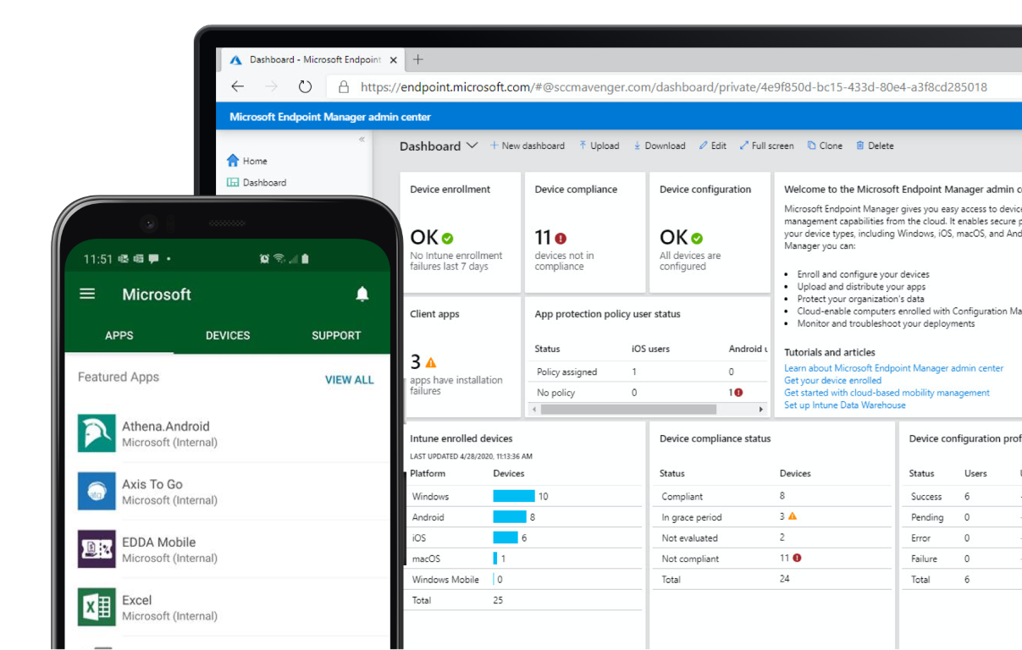

Microsoft Endpoint Manager Evaluation Lab Kit

Microsoft Intune | Microsoft Endpoint Configuration Manager

Set Up Guide

Last Updated: May 10, 2022

# Contents

Contents 2

1. Introduction 3

2. Hardware and Software Requirements 3

2.1. Hyper-V Host 3

2.2. Important Notes 3

3. Introduction to the Lab 4

4. Set Up the Lab 5

4.1. Create an External Virtual Switch in Hyper-V 5

4.2. Download and Extract the ZIP File 5

4.3. Setup the Lab 6

5. Cleanup and Re-Installation 6

6. Troubleshooting Tips 7

1. Introduction

This lab provides guidance on deploying and managing Windows 11 and Microsoft 365 Apps for enterprise using Microsoft Endpoint Manager. The lab uses the same lab environment as the **Windows 11 and Office 365 Deployment Lab Kit** which is available for free download in the Microsoft Evaluation Center.

[**Download the lab environment here**](https://www.microsoft.com/en-us/evalcenter/evaluate-windows-11-office-365-lab-kit)**.**

|  |
| --- |
|  |

1. Hardware and Software Requirements
   1. Hyper-V Host

The Windows 11 and Office Deployment Lab Kit is a testing environment based on Windows Server 2022 and Windows 11. It must be imported and created onto a Hyper-V server installed on Windows Server 2019 or later or Windows 10 or Windows 11.

It is recommended to use a Windows Server OS and should be fully updated. The Hyper-V Host must preferably meet the following specifications:

* Hyper-V role installed
* Administrative rights on the host
* 300 gigabytes of free disk space or more
* High-throughput disk subsystem
* Up to 32 gigabytes of memory
* Preferably a High-end processor for faster processing
* An External virtual switch in Hyper-V connecting to the external adapter of the host machine for internet connectivity, example **External 2**

**Note:** The above Memory and Processor requirements are just preferred requirements, however, you may run the lab with lesser Memory and Processor Speed by running fewer VMs, which means you do not have to run all the VMs all the time. When you are following a specific Lab, just run the VMs that are required in that Lab. Another point to note here is that the required hardware will vary based on the scale of the imported and created lab and the physical resources assigned to each virtual machine.

* 1. Important Notes

(Please read carefully before setting up the lab)

1. This lab consists of evaluation versions of Microsoft products. The Windows 11 client VMs expire on **August 7, 2022**. An updated lab kit with refreshed VMs will be published on or before that date.
2. DO NOT duplicate the Lab in your local environment. This is to avoid conflicts between the virtual machines.
3. In order to access Internet resources from the corporate network, rather than just the Internet, there might be a need to adjust the DNS Forwarder from something that is on the Internet to a DNS Server on the corporate network.
4. Introduction to the Lab

The Lab contains one self-extracting zip file:

**Win11_Lab.zip** (~25.0 GB) –It contains the exported Server based virtual machines and virtual hard disks along with the ServerParent.vhdx, WindowsParent.vhdx all compressed into a single Microsoft365DeviceLabKit.zpaq file, a Setup.exe for the Server and Client based virtual machines to be imported and created in Hyper-V, each virtual machine containing the evaluation products installed and configured to be used in the lab and a zpaq.exe file.The table below lists the virtual machines, which will be imported and created in Hyper-V:

| Server Name | Roles & Products |
| --- | --- |
| HYD-CLIENT1 | Windows 11 Domain Joined |
| HYD-CLIENT2 | Windows 11 Domain Joined |
| HYD-CLIENT3 | Windows 11 Workgroup |
| HYD-CLIENT4 | Windows 11 Workgroup |
| HYD-CLIENT 5, 6 | Bare metal (No Installations) |
| HYD-CM1 | Microsoft Endpoint Configuration Manager 2111  Windows Deployment Services  Windows Assessment and Deployment Kit for Windows 11 (10.1.22000)  Windows Software Update Services  Microsoft SQL Server 2017 |
| HYD-DC1 | Active Directory Domain Controller, DNS, DHCP, Certificate Services |
| HYD-GW1 | Remote Access for Internet Connectivity |
| HYD-INET1 | Simulated Internet |
| HYD-VPN1 | Remote Access for VPN |

The table below lists the credentials and access type available in the default implementation:

|  |  |  |  |
| --- | --- | --- | --- |
| User | Access Type | User Name | Password |
| Local Administrator | Administrative | Administrator | P@ssw0rd |
| Domain Administrator | Enterprise Administrator | CORP\LabAdmin | P@ssw0rd |

1. Set Up the Lab

These steps must be performed on an Internet-Connected Hyper-V Host machine:

* 1. Create an External Virtual Switch in Hyper-V

Before importing and creating the virtual machines in Hyper-V, one external virtual switch needs to be created in Hyper-V to provide Internet connectivity to the virtual machines.

1. Launch the Hyper-V Console and under **Actions**, click **Virtual Switch Manager**.
2. With the **New virtual network switch** selected, select **External** and click **Create Virtual Switch**.
3. Enter the name, example **External 2** and under **External network:** selected, select the network adapter providing Internet access to the Hyper-V Host and click **Apply**.
4. If prompted, click **Yes** on the Apply Networking Changes message box.
5. Click **OK** and close the Hyper-V Console.
   1. Download and Extract the ZIP File

Download the **Win11 Lab.zip** on the Hyper-V Host and extract the contents of the ZIP file to a separate folder.

**Note:** The name given to this separate folder should not include spaces as this may cause the lab provisioning process to fail.

* 1. Setup the Lab

Once the ZIP file has been extracted, the virtual machines then need to be imported and created into the Hyper-V Console using the provisioning Wizard in the lab.

1. Right-click **Setup.exe** and click **Run as administrator**.
2. Click **Yes** on the UAC prompt (if required).
3. The Wizard will launch. On the Welcome screen, click **Next**.
4. On the License screen, review the EULA and click **Next** to launch the lab provisioning process.
5. The wizard will start checking for the external virtual switch created in Section 3.1. Once detected, on the Ready screen, click **Next**.
6. The wizard will then extract contents from the .zpaq file, create the CorpNet and Internet virtual switches and import and create the Server and Client based virtual machines.

**Note:** Allow up to **15 minutes** for the wizard to extract the .zpaq file. Full provisioning of the lab will take up to **30 minutes.** (Performance will vary based on hardware.) The fully extracted lab will appear like this in the destination folder:

**IMPORTANT:** During the provisioning process, you can safely ignore any “Warnings” listed in the wizard during the provisioning process.

1. Once the provisioning process is complete, click the **Hyper-V Manager** link in the Wizard to launch the Hyper-V Console and click **Next** to close the wizard.

**Note:** Ensure that all the required services are running in the Server based virtual machines as per the Table in Section 2 above (This table lists the virtual machines, which will be imported and created in Hyper-V). If in case, they are stopped, start the services in those Server based virtual machines. Also, reboot the Server based virtual machines if they have a pending restart status.

1. Cleanup and Re-Installation

After the demonstration, clean up the environment by removing the virtual machines and virtual switches from the Hyper-V Console and delete the extracted folder. **Note:** Re-installing the lab from the extracted folder without following the clean-up steps below may cause the provisioning process to fail.

These steps must be performed on an Internet-Connected Hyper-V Host.

1. Launch the Hyper-V Console, select all the imported and created virtual machines and click **Turn Off**.
2. On the Turn Off Machine box, click **Turn Off**.
3. Once all the virtual machines are in turned off state, keeping them selected, click **Delete.**

**Note:** Before deleting the virtual machines, delete the Checkpoints from the virtual machines.

1. On the Delete Selected Virtual Machines box, click **Delete**.
2. Click **Virtual** **Switch Manager**.
3. Select **HYD-CorpNet** and **HYD-InterNet** virtual switches and click **Remove**. Click **Apply**.
4. Select the external virtual switch, example **External 2** and click **Remove**. Click **Apply**.
5. If prompted, click **Yes** on the Apply Networking Changes message box.
6. Click **OK** and then close the Hyper-V Console.
7. Permanently delete the manually created folder, **for example in the D drive** on the Hyper-V Host, where the ZIP file was extracted to. Click **Yes** on the Delete Folder box.
8. Troubleshooting Tips
9. Do not forget to unzip the Lab Kit files before running the setup application.
10. Do not use spaces in the manually created folder’s name. This is the folder where the zip file is extracted. Spaces can cause the import and creation of the virtual machines to fail.
11. The easiest way to address lab installation issues is to simply reinstall. To reinstall the lab, you must remove the virtual machines and virtual switches from the Hyper-V Console and delete the extracted folder. See Section 4.
12. Do not reinstall a lab from a previously extracted lab folder as this may cause the provisioning process to fail.
13. If one of the VMs does not immediately connect to the network, log into each VM and wait 5-10 minutes before remediating. If a VM is still not connecting, restart. If connectivity is still an issue, try adding the **External 2** virtual switch to the VM. In Hyper-V, select the VM and right-click to go to **Settings**. Select **Add Hardware > Network Adapter > Add** and select “**External 2**”.